Activation instructions

1. **Clone repository to local environment.**

<https://github.com/evya/FinalProject.git>

1. **Google Chrome Extention**
   1. **First Use**
      * Open Chrome
      * Go to
        + Chrome menu C:\Users\Evyatarp\Documents\PrintScreen Files\ScreenShot001.bmp
        + "Tools"
        + "Extensions"

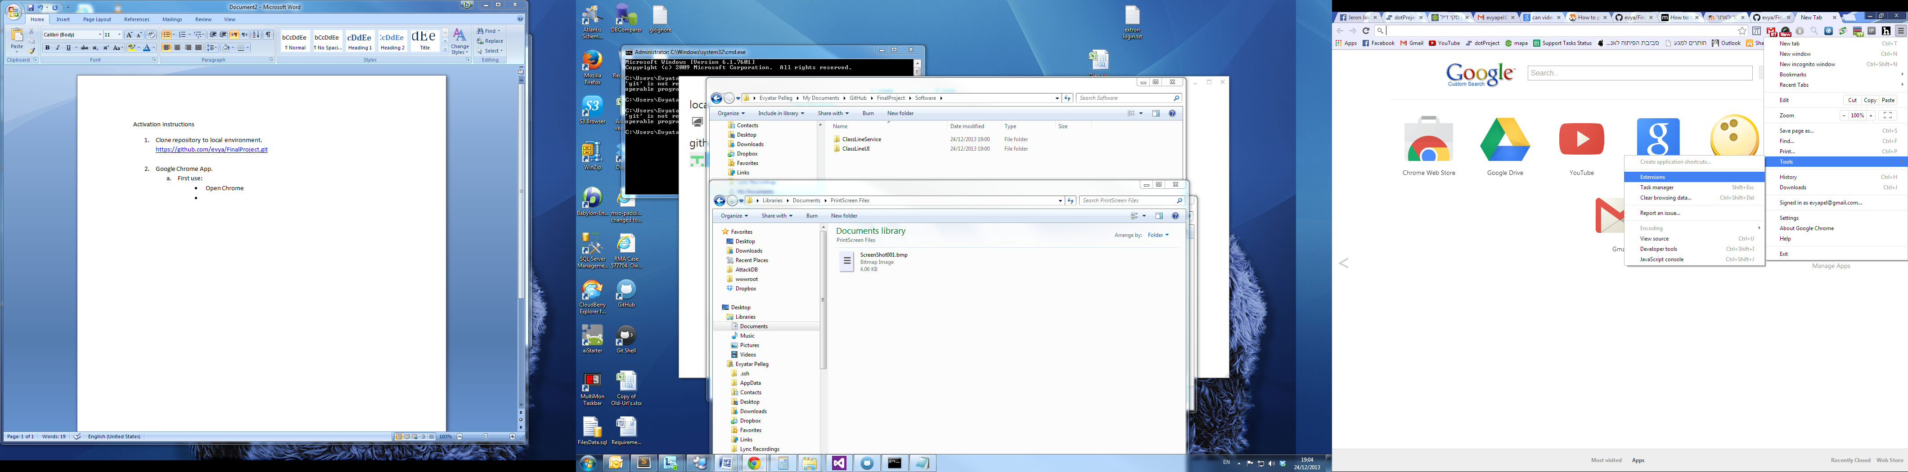

* + - Check the "Developer mode" checkbox

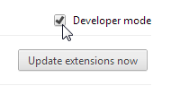

* + - Click "Load unpacked extension"

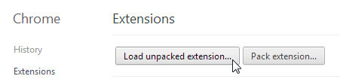

* + - Select the "ClassLineUI" directory and click "OK"

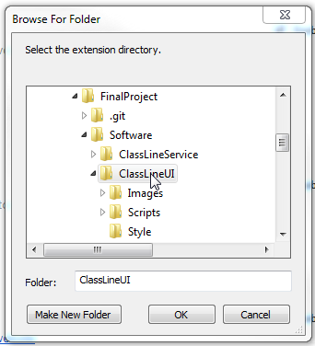

* + - The class line Chrome extension is ready for "Launch"

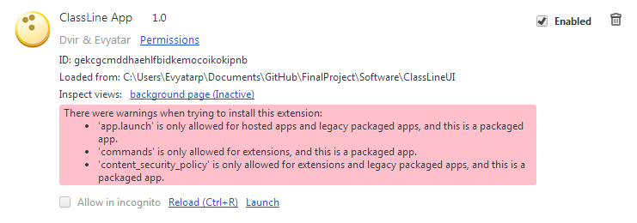

* 1. **Reoccurring use:**
     + Go to "Extentions" area



* + - Press "Launch" on the ClassLine App area

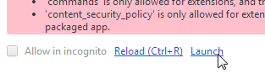

1. **Server Application**

* + - Access path <Local Repository> \ \FinalProject\Software\ClassLineService\ServerUI\bin\Debug
    - Double-click executable

